

**Matrix Digital Clock**

**Personal Project by Matthew Castleberry**

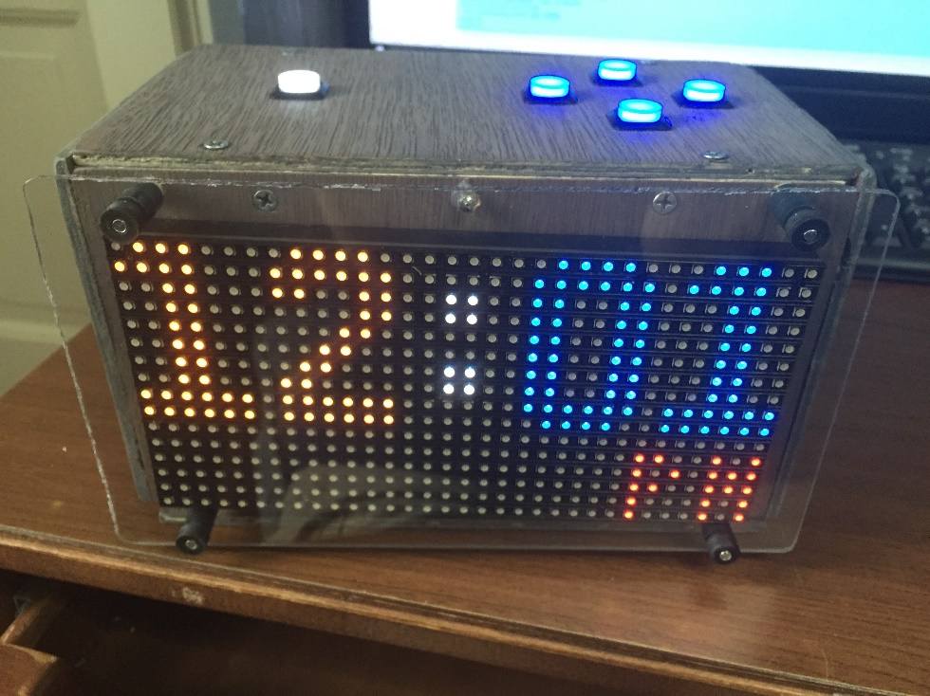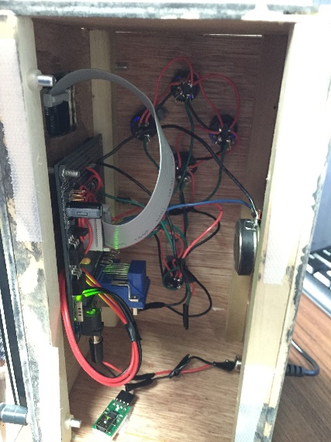

**Overview:**

The screen on my iHome clock was fading over time. I was afraid that eventually lose all visibility of the screen. Instead of buying a new clock I decided to build my own for the fun of it. This clock composed of the Adafruit 32x16 LED Matrix is controlled by the Parallax Propeller microcontroller. The Parallax Propeller is programmed in a language called SPIN that shares similarities to Basic, Python, and FORTRAN. The result was pretty cool. I built a nice wooden enclosure and mounted some lit push buttons on top. I currently use it as my main clock for my dorm room. Eventually some future functionality that I will possibly add is serial communication between the Raspberry Pi and Propeller in order to get the weather to display on the screen. I also hope to add alarm functionality to utilize the speaker I have built in to it.

**Github Project:** <https://github.com/mcberry23/Matrix-Clock>